Caused by: weblogic.transaction.RollbackException: Could not prepare resource 'DefaultDataSource_bpmdomain
JDBC driver does not support XA, hence cannot be a participant in two-phase commit. To force this participation, set the GlobalTransactionsProtocol attribute to LoggingLastResource (recommended) or EmulateTwoPhaseCommit for the Data Source = DefaultDataSource
at weblogic.transaction.internal.TransactionImpl.throwRollbackException(TransactionImpl.java:1884)
at weblogic.transaction.internal.ServerTransactionImpl.internalCommit(ServerTransactionImpl.java:376)
at weblogic.transaction.internal.ServerTransactionImpl.commit(ServerTransactionImpl.java:267)
at weblogic.transaction.internal.TransactionManagerImpl.commit(TransactionManagerImpl.java:307)
at org.springframework.transaction.jta.JtaTransactionManager.doCommit(JtaTransactionManager.java:1028)
... 43 more
Caused by: javax.transaction.xa.XAException: JDBC driver does not support XA, hence cannot be a participant in two-phase commit. To force this participation, set the GlobalTransactionsProtocol attribute to LoggingLastResource (recommended) or EmulateTwoPhaseCommit for the Data Source = DefaultDataSource
at weblogic.jdbc.wrapper.JTSXAResourceImpl.prepare(JTSXAResourceImpl.java:83)
at weblogic.transaction.internal.XAServerResourceInfo.prepare(XAServerResourceInfo.java:1343)
at weblogic.transaction.internal.XAServerResourceInfo.prepare(XAServerResourceInfo.java:513)
at weblogic.transaction.internal.ServerSCInfo.startPrepare(ServerSCInfo.java:392)
at weblogic.transaction.internal.ServerTransactionImpl.localPrepare(ServerTransactionImpl.java:2633)
at weblogic.transaction.internal.ServerTransactionImpl.globalPrepare(ServerTransactionImpl.java:2280)
at weblogic.transaction.internal.ServerTransactionImpl.internalCommit(ServerTransactionImpl.java:307)
... 46 more
.
.

这个是因为在数据库连接用了两个JNDI的datasource，一个事务（数据库连接）中包含了其他的事务（数据库连接）。
网上有人说要设置事务处理，如下：
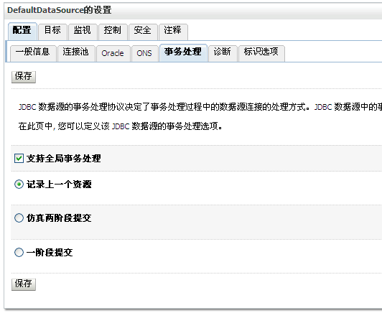
但是只是这样设置，程序执行时会报另外一个错：
Caused by: javax.transaction.SystemException: Cannot enlist more than one Non XA Resource. Attempt to enlist 'WL_JDBC_LLR_POOL.sotower' when 'WL_JDBC_LLR_POOL.DefaultDataSource' is already enlisted.
at weblogic.transaction.internal.ServerTransactionImpl.enlistResource(ServerTransactionImpl.java:762)
... 80 more

at weblogic.jdbc.jts.Driver.wrapAndThrowSQLException(Driver.java:603)
at weblogic.jdbc.jts.Driver.wrapAndThrowSQLException(Driver.java:583)
at weblogic.jdbc.jts.Driver.createLocalConnection(Driver.java:369)
at weblogic.jdbc.jts.Driver.connect(Driver.java:173)
at weblogic.jdbc.common.internal.RmiDataSource.getConnectionInternal(RmiDataSource.java:533)
at weblogic.jdbc.common.internal.RmiDataSource.getConnection(RmiDataSource.java:498)
at weblogic.jdbc.common.internal.RmiDataSource.getConnection(RmiDataSource.java:491)
at org.sotower.bpm.outapp.DBManager.getDBConnection(DBManager.java:65)
... 74 more

因此两个JNDI的datasource中必须有一个配成XA模式的。
如果是weblogic配置的源，要将其中的一个数据源的驱动选XA模式的。
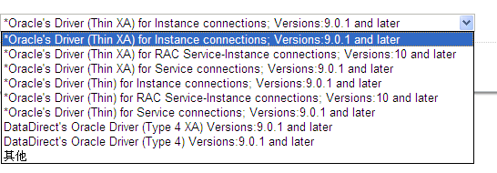
另外一个数据源配置事务处理，设置如下：

